Chicken and Leek Puff Pastry Slices with Garlic Herb Butter

This recipe is all about British leeks - gently cooked until sweet and folded into a creamy chicken filling, with pockets of garlicky herb butter hidden inside flaky puff pastry. A comforting, nostalgic dish that feels like home.

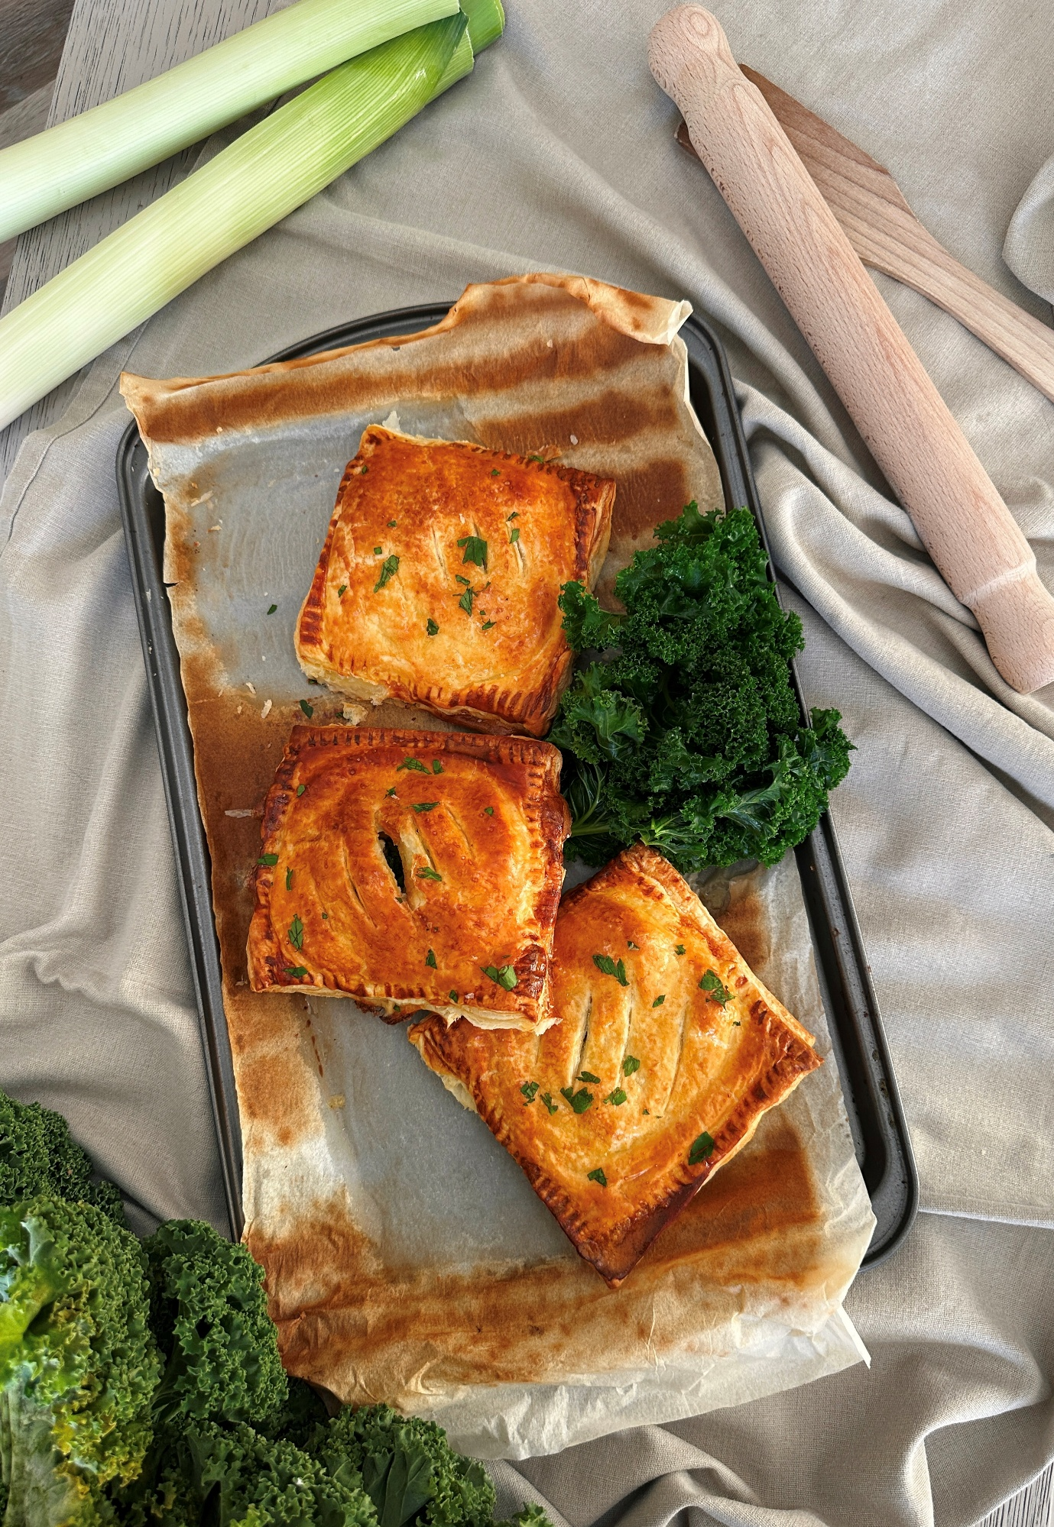
Serves: 4
Prep time: 15 minutes
Cooking time: 25-30 minutes

Ingredients

For the filling
4 roasted chicken thighs (or about 300g of meat after deboning)
120g leeks, thinly sliced
1 knob of butter
½ tsp minced garlic
2 tbsp plain flour
100ml double cream
100ml chicken stock
½ tsp fresh thyme, chopped
½ tsp salt
Freshly ground black pepper, to taste

For the garlic herb butter
2 tbsp butter, softened
2 garlic cloves, minced
5g fresh parsley, chopped

For the pastry
1 sheet puff pastry (around 375g)
1 egg, beaten (for egg wash)

Prepare the filling
- Using roasted chicken thighs (recommended for a juicier, more flavourful filling), remove the meat from the bones and discard the skin. Chop the meat into small, bite-sized pieces - you don’t need to be exact, just aim for roughly uniform chunks that will fit nicely inside the pastry.
- Slice the leeks thinly into roughly 5mm coins.
- In a frying pan over medium heat, melt the knob of butter. Add the leeks and minced garlic and cook gently for 2-2½ minutes until softened but not browned.
- Sprinkle in the plain flour and cook for 1-2 minutes, stirring continuously, to remove the raw flour taste.
- Pour in the double cream and chicken stock. Stir in the thyme, salt, and black pepper. Let it cook for 2 minutes until slightly thickened.
- Add the chopped chicken and heat through for 1-2 minutes. Remove from the heat and allow to cool slightly.

Make the garlic herb butter
- Combine the softened butter, minced garlic, and chopped parsley in a small bowl. Mix until well combined.

Assemble the puff pastry slices
- Preheat the oven to 190°C / 374°F / 170°C fan / Gas mark 5 and line a baking tray with parchment paper.
- Roll out the puff pastry sheet and cut to your desired size.
- Spoon a portion of the chicken and leek filling onto the pastry.
- Add small dollops of the garlic herb butter on top of the filling, gently pressing it in so it “nests” into the filling.
- Cover with the top layer of pastry and seal the edges. Brush the top with beaten egg for a golden finish. Make a slit into the pastry with a knife.

Bake
- Bake in the preheated oven for 20-25 minutes, or until the pastry is puffed and golden brown.

Please credit www.Britishleeks.co.uk, photography, recipe & styling by JessHallCooks

